HC 1 T3 U1
 | 題目 | 圖片
1 | It's small. | 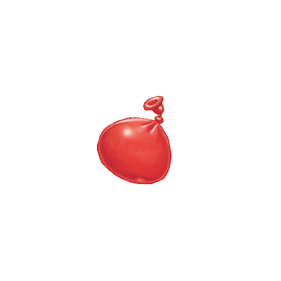
2 | It's big. | 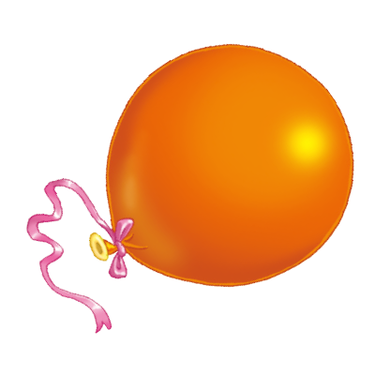
3 | It's long. | 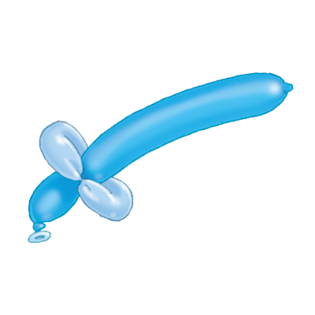
4 | It's short. | 